Non-ideal effects in doped semiconductor thermistors
M. Galeazzi*, K. R. Boyce†, R. Brekosky†, J. D. Gygax†, R. Kelley†, D. Liu*, D. McCammon*, D. B. Mott†, F. S. Porter†, W. T. Sanders*, C. K. Stahle†, C. M. Stahle†, A. E. Szymkowiak†, and P. Tan*
*University of Wisconsin, Madison, WI 53706 USA
†NASA/Goddard Space Flight Center, Greenbelt, MD 20771 USA
Abstract. Semiconductor thermistors have been used for several years and their ideal behavior is well known both experimentally and theoretically. Their current performance is limited by non-ideal behaviors. These include 1/f noise and non-ohmic effects. We find that the 1/f noise appears to be a 2-D effect, and can be greatly reduced by fabricating thicker thermistors. Eliminating this noise could improve the intrinsic detector resolution as much as 40%. It also allows us to study other sources of excess noise in the thermometer. The non-ohmic behavior can be empirically explained using a hot-electron model. Although this model does not seem suitable for semiconductors in the variable range-hopping regime, where the electrons are localized, it fits the experimental data quite well. We measured an excess white noise at low frequencies consistent with the predicted thermodynamic fluctuations between electrons and phonons. We also measured a characteristic time of the non-ohmic behavior that is consistent with a C/G time constant in the hot electron model. Both results support the physical validity of the hot electron model. To optimize the performance of the next generation of detectors, we implemented the non-ideal behaviors in a model to predict the expected total noise and energy resolution. The comparison between the model and real data from the XRS experiment show good agreement.

introduction
Our work is based on two main motivations: the existing thermistors exhibit a significant level of excess 1/f noise that limits the energy resolution, and the desired array designs do not have enough area on the pixels for thermistors of the volume required to optimize performance taking into account non-ohmic effects of the thermistor.
The fabrication of thicker Si thermistors (1500 nm compared with 250 nm) has reduced the level of 1/f noise to a negligible contribution [1]. Moreover, increasing thermistor thickness also allows the volume to be optimized for non-ohmic effects within the area available on the pixels.
The strong reduction of the 1/f noise contribution also allowed us a better study of the non-ohmic behavior of the thermistors [2]. In fact, with the disappearance of the 1/f noise a new and somehow unexpected noise term became evident, i.e. the noise coming from the thermal fluctuations between electron and phonon systems. The existence of this excess noise, together with the measurement of the heat capacity of the electron system, strongly supports the physical validity of the hot-electron model. The model assumes, in analogy of what happens in metals, that electrons and phonons constitute two different systems that are in thermal contact [2].
With the new information about 1/f noise and non-ohmic behavior we have also been able to build a quite realistic model of a microcalorimeter, whose predictions are in perfect agreement with experimental results [3].
Rather than discuss in detail the measurements and the experimental results that are described elsewhere in this volume [1-3], here we will give an overview of what has been done in order to improve the performance of the thermistors and to better understand their behavior. We will also describe the technique used to make thicker thermistors.

1/f noise
We have characterized the 1/f noise in standard ion-implanted silicon thermistors, which are about 250 nm thick. We find that it is associated with the bulk of the implant, and is interpretable as a ΔR/R fluctuation that is independent of the bias and depends only on the doping density and resistivity, or electron temperature. This excess noise is large enough that it has a significant effect on the energy resolution or NEP of a detector using these thermistors.
The very steep temperature dependence of the observed 1/f noise led us to suspect that it might be a 2–d effect, related to the fact that the predicted size of the percolation networks is approaching the 250 nm thickness of the standard implants at the temperatures of interest, and is increasing exponentially as the temperature is reduced. The thickness of these implants is limited by the ion energies available with a standard implanter, but a high-energy implanter was available and we have now fabricated thermistors with a thickness of 1500 nm. These thicker thermistors have no detectable 1/f noise. This simple change could provide a 40% improvement in resolution for some existing X-ray detectors.

NON-ohmic behavior
Non-ohmic behavior of doped silicon and germanium can be empirically explained using a hot-electron model, which is motivated by the hot-electron effect in metals at low temperatures. This model assumes that the thermal coupling between electrons and lattice at low temperatures is weaker than the coupling between electrons, so that the electric power applied to the electrons raises them to a higher temperature than the lattice. Although this model does not seem suitable for semiconductors in the variable range-hopping regime, where the electrons are localized, it fits quite well the experimental data.
To determine whether the hot-electron model in doped semiconductor is just an alternative way to parameterize the data or has some physical validity, we investigated the noise and frequency-dependence of the impedance of doped silicon thermistors that are used for low temperature thermal X-ray detectors. The measured excess white noise at low frequencies is consistent with the predicted thermodynamic fluctuations of energy between electron and phonon systems. The non-ohmic behavior shows a characteristic time that can be interpreted as a C/G time constant in the hot-electron model. By measuring this time constant, we get a hot-electron heat capacity C that agrees with the measured excess heat capacity of the implants. This supports the assumption of a hot-electron system thermally separated from the lattice system [2].

Modeling of detector performances
We have constructed an analytical detector model that includes the effect of a sensor hot electron system that is thermally connected to the lattice structure of the detector, and an absorber that is thermally connected, but physically separated from the structure of the detector. The noise analysis incorporates terms for thermistor Johnson and 1/f noise, amplifier noise, load resistor Johnson noise, and thermodynamic fluctuations between the electron and phonon systems in the thermometer as well as between the absorber, the thermistor, and the heat sink. For the calculation, block diagram algebra, traditionally used in electrical engineering, has been demonstrated to be a very powerful tool for the complex calculations necessary in our model. The model has been checked by comparing its predictions to data obtained from existing detectors developed for the XRS spectrometer on Astro-E.

Fabrication of 1.5 μm thick implants
Implanted thermistors are normally made by implanting the dopant ions into a standard silicon wafer (about 400 μm thick) at several different energies. Each energy gives a gaussian distribution of doping density at a different depth below the surface. The doses and energies are calculated to result in a close approximation to a flat-topped profile of the desired density, as shown in Fig. 1 (left).
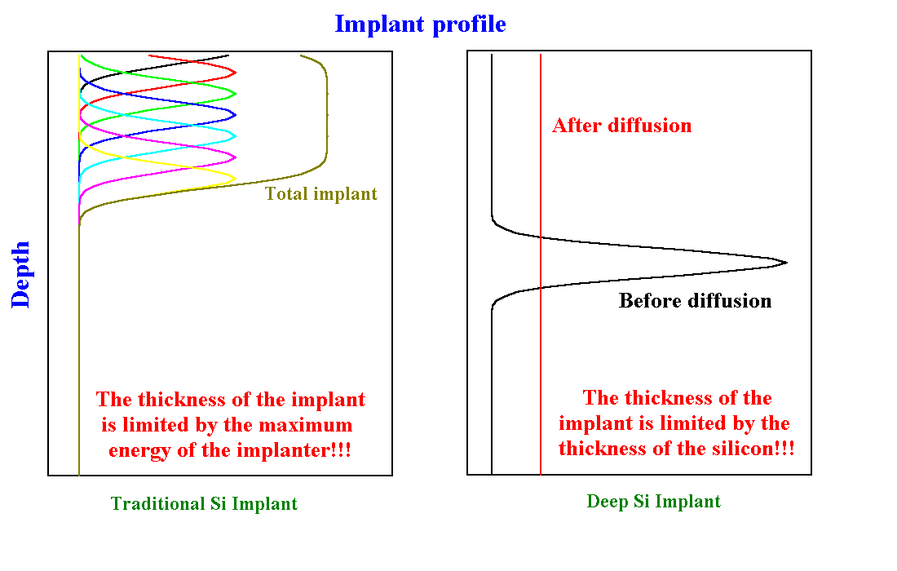
Figure 1. Schematic view of implant profile in traditional Si implant (left) and in diffused Si implant (right).
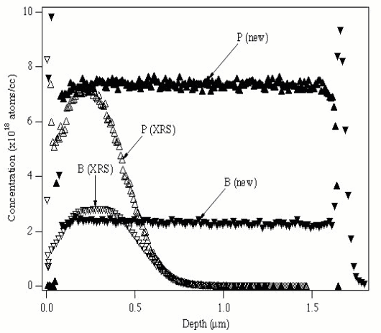
Figure 2. SIMS measurement of a traditional Si implant (empty triangles) and of a diffused Si implant (full triangles). The peaks at the two sides of the implant are just an artifact of the SIMS measurement.

The implants are annealed carefully to avoid excessive diffusion that would spoil the implanted profile. Most groups using these thermistors have made them about the same thickness because standard ion implanters usually have maximum energies around 300 keV (some of them can reach 400 keV), which gives a range for a flat profile of phosphorous ions of about 250 nm. Higher energy implanters are now available, but the availability of silicon-on-insulator wafers that have a buried oxide layer under about 1.5 μm of silicon enables a simpler process for making a flat-top profile (see Fig. 2). A single implant is made at an energy that gives a range near the middle of the thin silicon layer, as shown in Fig. 1 (right). The wafer is then subjected to a much hotter and longer annealing cycle, which allows the implanted ions to diffuse throughout the 1.5 μm silicon layer. Diffusion is blocked by the free surface and by the buried oxide layer, so that a completely rectangular profile is obtained. The implants have a badly-diffused lateral gradient at the edges, but this is physically removed by cutting the silicon away at the edges of the thermometer when the thin layer is etched to form the thermal isolation supports.

References
1. McCammon, D., et al., “1/f Noise in Doped Semiconductor Thermistors” in 9th International Workshop on low temperature detectors – Madison, WI, 2001, edited by D. McCammon And F. S. Porter, AIP Conference Proceedings, New York: American Institute of Physics, this volume.
2. Liu, D., et al., “Hot-Electron Model in Doped Silicon Thermistors” in 9th International Workshop on low temperature detectors – Madison, WI, 2001, edited by D. McCammon And F. S. Porter, AIP Conference Proceedings, New York: American Institute of Physics, this volume.
3. Galeazzi, M., et al., “Performance Modeling of Microcalorimeter Detectors” in 9th International Workshop on low temperature detectors – Madison, WI, 2001, edited by D. McCammon And F. S. Porter, AIP Conference Proceedings, New York: American Institute of Physics, this volume.

