Hot-electron Model in Doped Silicon Thermistors
D. Liua, M. Galeazzia, D. McCammona, W. T. Sandersa, B. Smitha, P. Tana, K.R. Boyceb, R. Brekoskyb, J.D. Gygaxb, R. Kelleyb, D.B. Mottb, F. S. Porterb, C. K. Stahleb, C.M. Stahleb, and A. E. Szymkowiakb

ª University of Wisconsin, Madison, WI 53706 USA
^{b} NASA/Goddard Space Flight Center, Greenbelt, MD 20771 USA

Abstract. Non-ohmic behavior of doped silicon and germanium can be empirically explained using a hot-electron model, which is motivated by the hot-electron effect in metals at low temperatures. This model assumes that the thermal coupling between electrons and lattice at low temperatures is weaker than the coupling between electrons, so that the electric power applied to the electrons raises them to a higher temperature than the lattice. Although this model seems not suitable for semiconductors in the variable range-hopping regime, where the electrons are localized, it fits quite well the experimental data. To determine whether the hot-electron model in doped semiconductor is just an alternative way to parameterize the data or has some physical validity, we investigated the noise and the frequency-dependence of the impedance of doped silicon thermistors that are used for low temperature thermal X-ray detectors. The measured excess white noise at low frequencies is consistent with the predicted thermodynamic fluctuations of energy between electron and phonon systems. The non-ohmic behavior shows a characteristic time that can be interpreted as a C/G time constant in the hot-electron model. By measuring this time constant, we get a hot-electron heat capacity C that agrees with the measured excess heat capacity of the implants. These support the assumption of a hot-electron system thermally separated from the lattice system.

I. introduction
Non-Ohmic effects of ion-implanted silicon thermistors can be well described by the "hot-electron" model [1], where it is assumed that the resistance depends only on the temperature of the electrons, but there is a thermal resistance between the electrons and the crystal lattice through which the bias power must flow, increasing the temperature of the electrons above the temperature of the lattice, and therefore reducing the thermistor resistance.

Figure 1 shows the resistance of a thermistor as a function of the Joule power for different phonon (lattice) temperatures ranging from 50 mK to 150 mK.
The lines are the result of a fit to the hot-electron model, with a power-law dependence of thermal conductivity on temperature. The hot-electron model seems to fit very well and the parameters derived are in good agreement with the previous results [1].

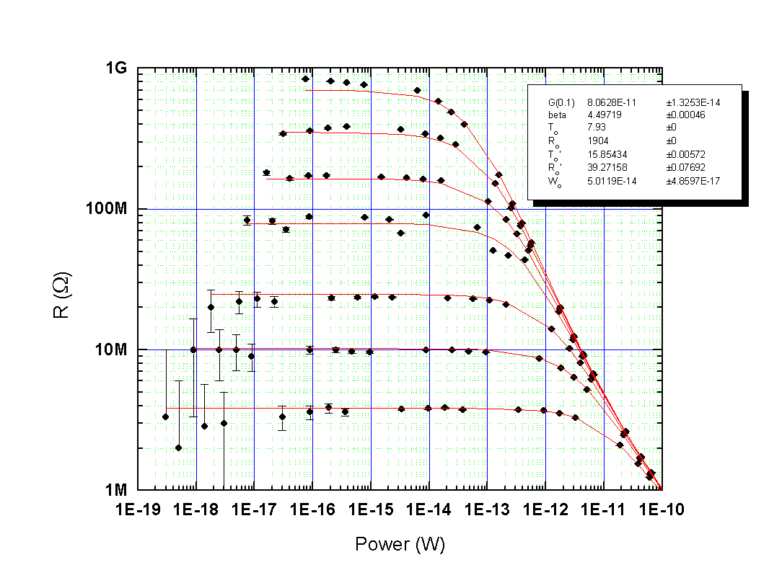
Figure 1. The resistance-vs.-Joule power plot of a silicon thermistor, with the lattice temperature ranging from 50mK to 150mK. Each curve is the result of the fit to the hot-electron model at the corresponding electron temperature.

Hot-electron effects are well-understood in metals [4-8], but in hopping semiconductors the electrons are expected to be localized in the lattice and therefore the theory does not predict any hot-electron behavior. In order to find out whether the hot-electron effect is physical in doped semiconductors, despite the theoretical predictions, we studied other effects that it would generate. The study of the excess noise and the frequency-dependence of the non-linear effects of the silicon thermistors give us more experimental supports to the physical validity of this model. The devices that we tested have a wide variety of dimensions, with thickness of either about 1.5 μm or 0.3 μm, areas between 2.5×10⁻⁵ cm² and 1.6×10⁻³cm², and geometries between 1×36 and 36×1.

II. interpreting the excess white noise
The hot-electron model can be used to explain the excess white noise that we measured in implanted silicon thermistors.

During the characterization of thick silicon thermistors, we measured the noise between 3 Hz and 30 kHz on devices in strong thermal connection with the cold plate of the refrigerator (i.e. the devices were not suspended and the chip they were mounted on was glued to the cold plate) under different bias conditions. The phonon noise due to thermal fluctuation between the devices and the heat sink is expected to be negligible due to the strong thermal link. The only appreciable noise contribution expected was Johnson noise, but we found that, for bias currents greater than zero, the devices produce an excess noise. This excess noise is flat at low frequencies and has a roll-off at about 500-5,000 Hz due to the stray capacitance of the FET readout electronics.
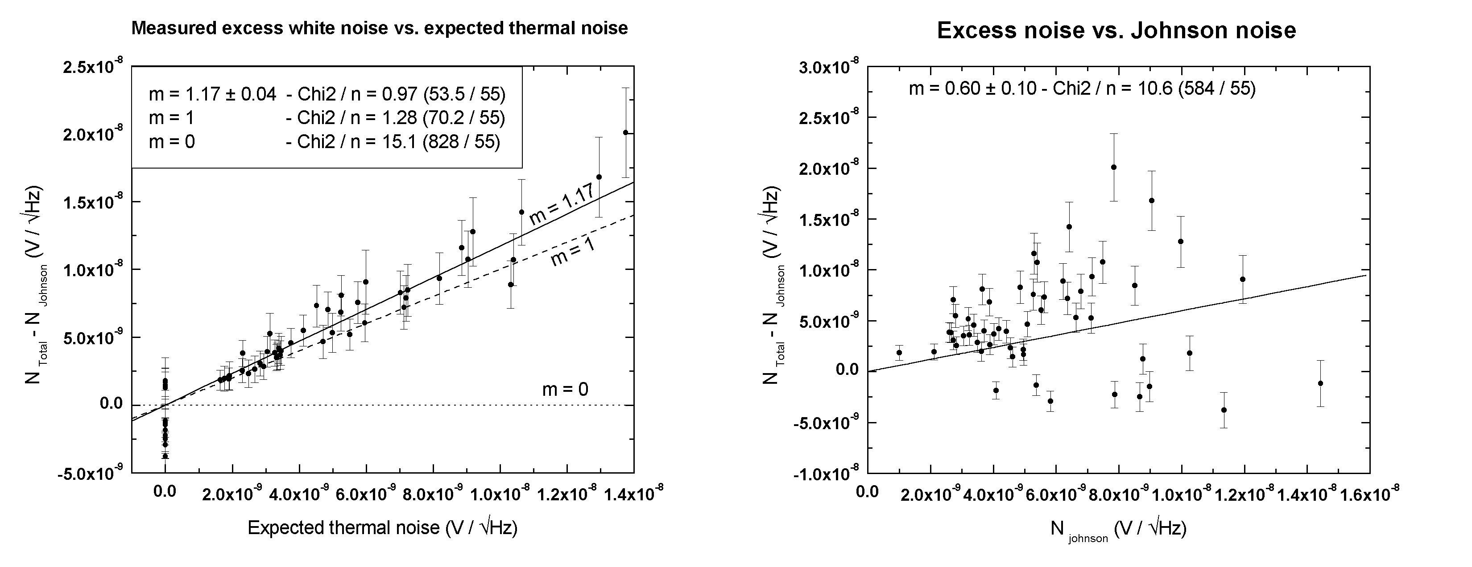
FIGURE 2. The left figure shows the good fit of the measured excess white noise to the expected thermal noise from the hot-electron model. The data are taken from several deep-implanted samples. The right figure shows that the excess white noise is not linear with the Johnson noise, thus makes sure that it is not due to an underestimate of the Johnson noise.

We then tried to explain this excess noise in the context of the hot-electron model. If the electrons and phonons are really two separate systems connected through a thermal conductivity Ge-ph, we expect, in addition to the Johnson noise, to see the noise due to thermal fluctuations between the two systems [2,3].

Figure 2 (left) shows the measured excess noise as a function of the expected phonon noise due to the thermal link between electrons and phonons. In the calculations, for the value of the thermal conductivity we used the value obtained from the fit of the resistance-vs.-power plot. The plot shows a strong correlation between the observed excess noise and the expected thermal noise, with a linearly fit with a slope of nearly 1. This strongly supports the idea that the excess noise is due to thermal fluctuations between electrons and phonons, and that the hot-electron model may be something more than just a good empirical way to explain the non-ohmic behavior of semiconductor thermistors.
We also considered the possibility that only Johnson noise exists and that the excess noise is due to an underestimate of it. If this were the case, there should be a systematic error apparent in our measurements, and the excess noise should scale with the expected Johnson noise. To make sure that this is not the case, we made a plot of excess noise vs. expected Johnson noise in figure 2 (right). In this plot, the data points are widely scattered, and cannot be reasonably fitted in any way. Therefore, the apparent excess noise doesn’t seem to be related in any way to the Johnson noise.

III. heat capacity of The hot-electron system
Assuming that the hot-electron model describes a real physical property of silicon thermistors, we considered other effects predicted by this model and tried to experimentally see them. In particular, if the electrons constitute a separate system, we expect them to have a heat capacity Ce greater than zero. This heat capacity combines with the thermal conductivity Ge-ph, and should show up as a characteristic time constant in the resistance non-linearity with a value equal to Ce/Ge-ph.
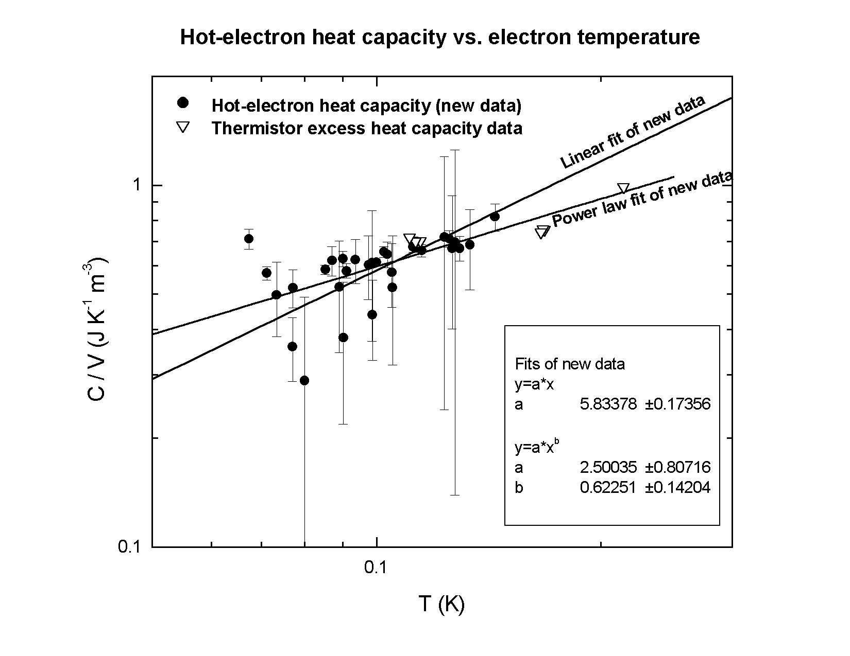
FIGURE 3. The hot-electron heat capacity obtained from the measured characteristic time C/G and the heat conductance G. The data show a power-law dependent on the electron temperature and a good agreement with the measured thermistors excess heat capacity.

We therefore measured the dynamic impedance Z(ω) [2] of different thermistors under several bias conditions. Since these devices are in strong thermal contact with the heat sink, the time constant between the thermistors and the heat sink should be zero, and any time constant characterizing Z(ω) must come from the hot-electron system. Fitting the measured dynamic impedance we obtain, in fact, a time constant Ce/Ge-ph that is different from zero, which implies that there is a heat capacity, or something that behaves like a heat capacity associated with the hot-electron system. Moreover, we estimate the value of the heat capacity Ce using the Ge-ph obtained through the resistance-vs.-power curves.
Figure 3 shows the plot of Ce vs. electron temperature. The data from different thermistors and under different bias conditions seem to be consistent to each other, with a power-law dependence on the temperature that has an index smaller than one. The error bars are mainly due to stray capacitances in the electrical circuit that limit the accuracy in the measurement of the time constant.
The results are in good agreement with the measured total excess heat capacity associated with the thermistor (shown in figure 3). Those values were obtained by taking the difference of the total heat capacity of two detectors that were identical except for an extra thermistor implant on one of them.

References
1. Zhang, J., Cui. W., Juda, M., McCammon, D., Kelley, R. L., Moseley, S. H., Stahle, C. K., and Szymkowiak, A. E., Phys. Rev. B 57, 4472-4481 (1998).
2. Mather, J. C., Appl. Opt. 21, 1125-1129 (1982).
3. Moseley, S. H., Mather, J. C., and McCammon, D., J. Appl. Phys. 56, 1257-1262 (1984).
4. Little, W. A., Can. J. Phys. 37, 334-349 (1959).
- Shklovskij, V. A., J. Low Temp. Phys. 41, 375-396 (1980).
- Anderson, A. C., and Peterson, R. E. Phys. Lett. 38A, 519-520 (1972).
- Anderson, P. W., Abrahams, E., and Ramakrishnan, T. V., Phys. Rev. Lett. 43, 718-720 (1979).
- Roukes, M. L., Freeman, M. R., Germain, R. S., Richardson, R. C., and Ketchen, M. B., Phys. Rev. Lett. 55, 422-425 (1985).

